UNITED STATES

SECURITIES AND EXCHANGE COMMISSION
WASHINGTON, D.C. 20549

FORM 8-K

CURRENT REPORT

Pursuant to Section 13 or 15(d)
of the Securities Exchange Act of 1934

Date of Report (Date of earliest event reported): February 13, 2024

KALVISTA PHARMACEUTICALS, INC.

(Exact Name of Registrant as Specified in its Charter)

Delaware

001-36830

20-0915291

(State or Other Jurisdiction
of Incorporation)

(Commission
File Number)

(IRS Employer
Identification No.)

55 Cambridge Parkway

Suite 901E

Cambridge, Massachusetts 02142
(Address of Principal Executive Offices) (Zip Code)

(857) 999-0075

(Registrant’s telephone number, including area code)

N/A

(Former name or former address, if changed since last report)

Check the appropriate box below if the Form 8-K filing is intended to simultaneously satisfy the filing obligation of the registrant under any of the following provisions:

- Written communications pursuant to Rule 425 under the Securities Act (17 CFR 230.425)

- Soliciting material pursuant to Rule 14a-12 under the Exchange Act (17 CFR 240.14a-12)

- Pre-commencement communications pursuant to Rule 14d-2(b) under the Exchange Act (17 CFR 240.14d-2(b))

- Pre-commencement communications pursuant to Rule 13e-4(c) under the Exchange Act (17 CFR 240.13e-4(c))

Securities registered pursuant to Section 12(b) of the Act:

Title of each class |  | Trading |  | Name of each exchange
 |  | symbol(s) |  | on which registered
Common Stock, $0.001 Par Value Per Share |  | KALV |  | The Nasdaq Stock Market LLC

Indicate by check mark whether the registrant is an emerging growth company as defined in Rule 405 of the Securities Act of 1933 (§230.405 of this chapter) or Rule 12b-2 of the Securities Exchange Act of 1934 (§240.12b-2 of this chapter).

Emerging growth company ☐

If an emerging growth company, indicate by check mark if the registrant has elected not to use the extended transition period for complying with any new or revised financial accounting standards provided pursuant to Section 13(a) of the Exchange Act. ☐

Item 7.01. Regulation FD Disclosure.

On February 13, 2024, KalVista Pharmaceuticals, Inc. (“the Company”) issued a corporate presentation slide deck with information including clinical data from the Company’s Phase 3 KONFIDENT clinical trial (the “KONFIDENT trial”).

Additionally, on February 13, 2024, the Company issued a press release announcing clinical data from the KONFIDENT trial.

A copy of the corporate presentation is attached as Exhibit 99.1 to this Current Report on Form 8-K. A copy of the press release is attached as Exhibit 99.2 to this Current Report on Form 8-K.

The information furnished in this Item 7.01, including Exhibits 99.1 and 99.2, shall not be deemed “filed” for purposes of Section 18 of the Securities Exchange Act of 1934, as amended (the “Exchange Act”), or otherwise subject to the liabilities of that section, nor shall it be deemed incorporated by reference into any other filing under the Exchange Act or the Securities Act of 1933, as amended, except as expressly set forth by specific reference in such a filing.

Item 8.01. Other Events.

On February 13, 2024, the Company announced clinical data from the KONFIDENT trial. Program updates and updated data are summarized as follows:

The KONFIDENT trial met all primary and key secondary endpoints and demonstrated a favorable safety profile. Hereditary Angioedema (“HAE”) attacks treated with both 300 mg and 600 mg of sebetralstat achieved the primary endpoint of beginning of symptom relief significantly faster than placebo (p<0.0001 for 300 mg, p=0.0013 for 600 mg). The median time to beginning of symptom relief was 1.61 hours with sebetralstat 300 mg (CI 1.28, 2.27), 1.79 hours with sebetralstat 600 mg (CI 1.33, 2.27) and 6.72 hours with placebo (CI 2.33, >12).

Consistent with previous trials, sebetralstat was well-tolerated, with a safety profile similar to placebo. The KONFIDENT trial had no patient withdrawals due to any adverse event and no treatment-related serious adverse events.

Primary and key secondary endpoints were analyzed in a fixed, hierarchical sequence and adjusted for multiplicity. Key secondary endpoints showed:

- HAE attacks treated with sebetralstat 300 mg or 600 mg achieved a significantly faster time to a reduction in attack severity from baseline, compared to placebo (p=0.0036 for 300 mg and p=0.0032 for 600 mg)

- HAE attacks treated with sebetralstat 300 mg or 600 mg demonstrated a significantly faster time to complete attack resolution, compared to placebo (p=0.0022 for 300 mg and p<0.0001 for 600 mg)

The Company plans to present Phase 3 data for the KONFIDENT trial at the annual meeting of the American Academy of Allergy Asthma and Immunology on February 25, 2024.

Item 9.01. Financial Statements and Exhibits

(d) Exhibits

Exhibit
No. Description

99.1 Corporate Presentation

99.2 Press Release, dated February 13, 2024

104 Cover Page Interactive Data File (embedded within the Inline XBRL document)

Forward-Looking Statements

This Current Report on Form 8-K contains forward-looking statements within the meaning of the U.S. Private Securities Litigation Reform Act of 1995 and other federal securities laws. Any statements contained herein that do not describe historical facts, including, but not limited to, statements we make regarding our business plans and objectives, timing and success of our planned nonclinical and clinical development activities, timing and results of nonclinical studies and clinical trials, efficacy and safety profiles of our product candidates, any expectations about safety, efficacy of sebetralstat and our ability to obtain regulatory approvals for sebetralstat and other candidates in development, the ability of sebetralstat to treat hereditary angioedema (HAE), the potential therapeutic benefits and economic value of our product candidates, potential growth opportunities, competitive position, industry environment and potential market opportunities, our ability to protect intellectual property and the impact of global business or macroeconomic conditions, including as a result of inflation, rising interest rates, instability in the global banking system, and geopolitical conflicts, including the conflicts in Ukraine and the Middle East, on our business and operations . Such risks and uncertainties include, among others, the risks identified in the Company’s filings with the Securities and Exchange Commission (the “SEC”), including its Annual Report on Form 10-K for the year ended April 30, 2023, filed with the SEC on July 10, 2023, and other reports as filed with the SEC. The Company cautions you not to place undue reliance on any forward-looking statements, which speak only as of the date they are made. The Company undertakes no obligation to update publicly any forward-looking statements to reflect new information, events or circumstances after the date they were made or to reflect the occurrence of unanticipated events.

SIGNATURES

Pursuant to the requirements of the Securities Exchange Act of 1934, as amended, the registrant has duly caused this report to be signed on its behalf by the undersigned thereunto duly authorized.

KALVISTA PHARMACEUTICALS, INC.

By: /s/ Benjamin L. Palleiko

Benjamin L. Palleiko

President, Chief Business Officer and Chief Financial

Officer

Date: February 13, 2024

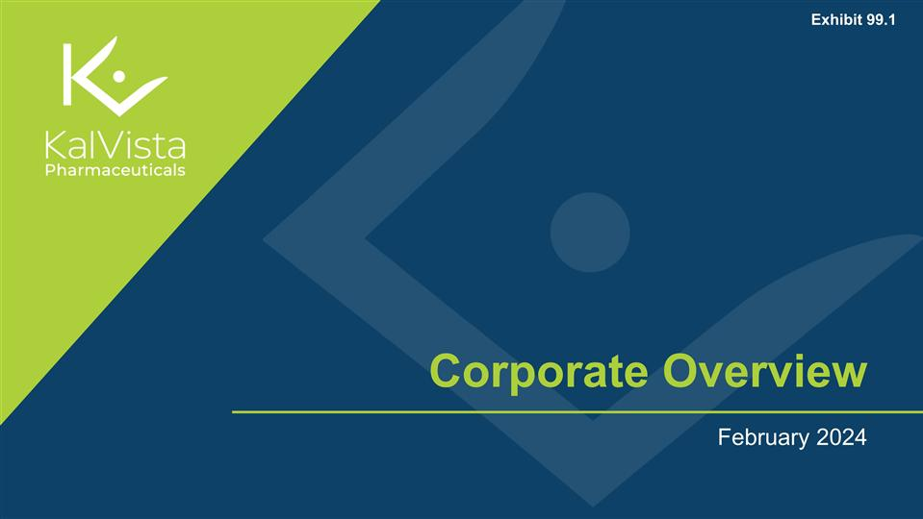

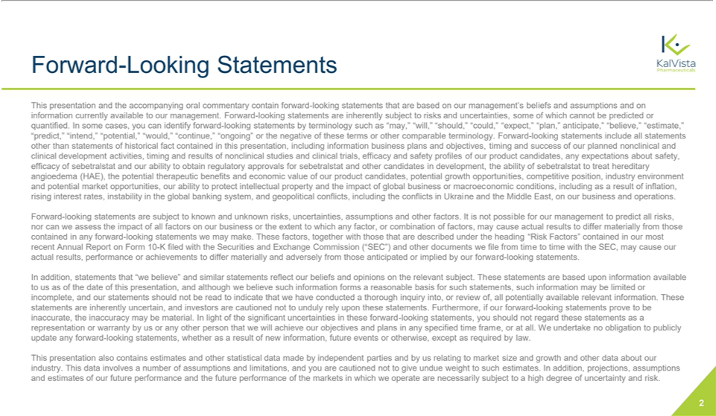

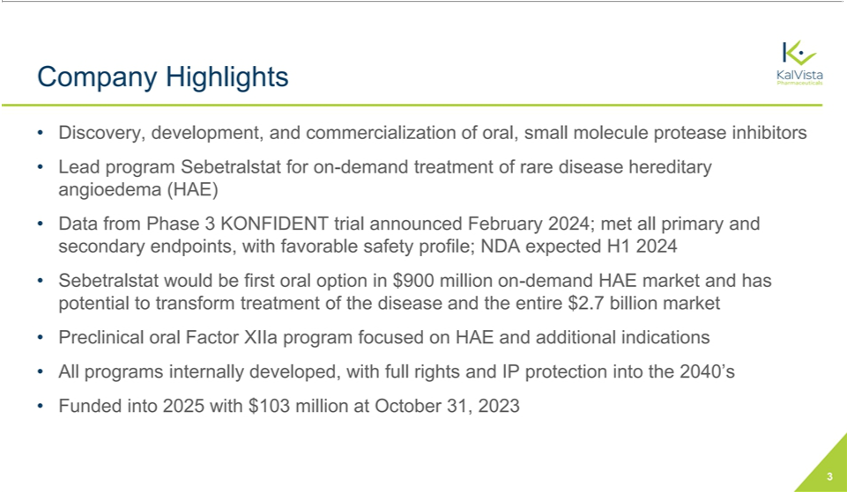

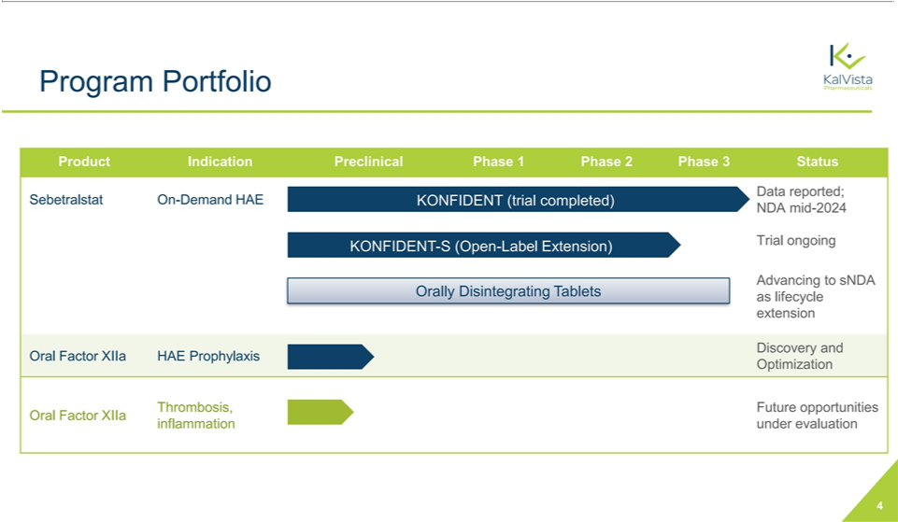

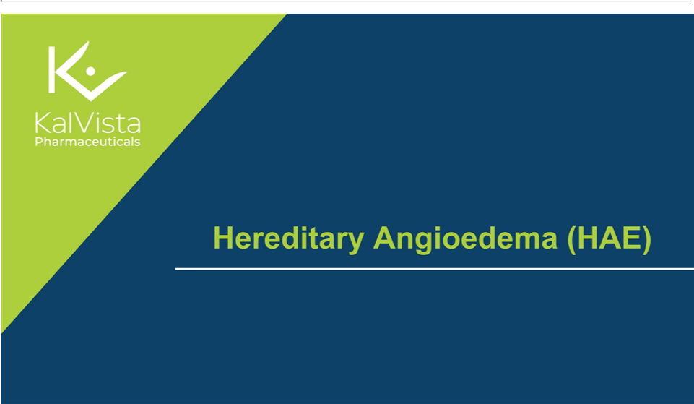

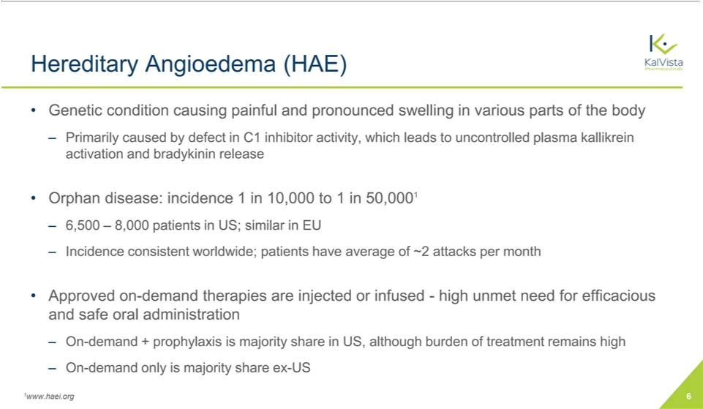

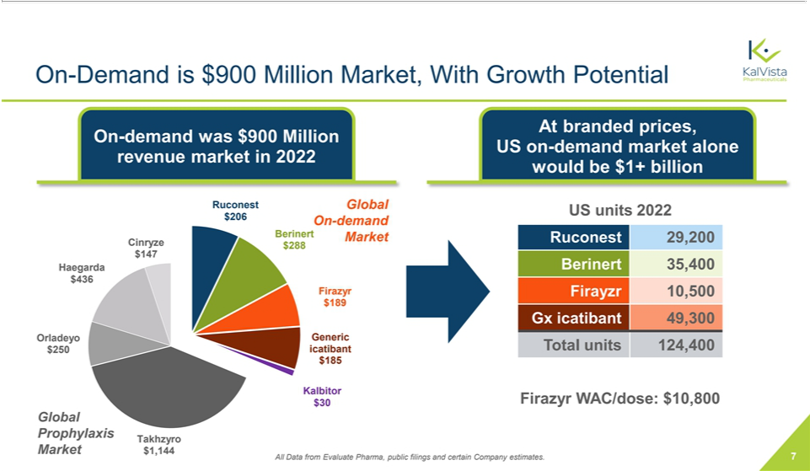

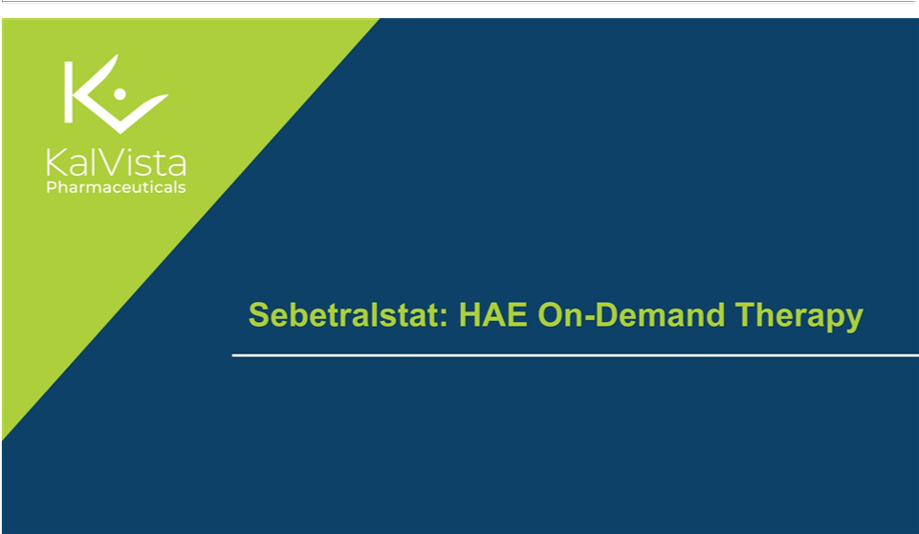

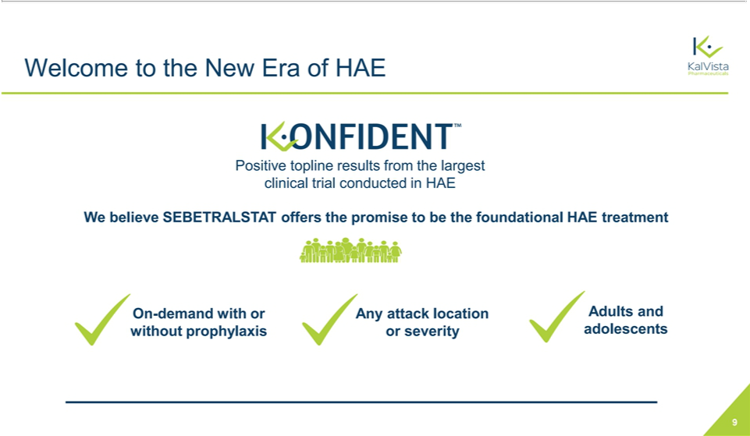

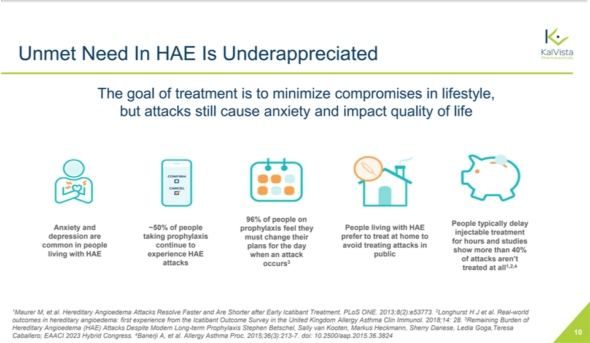

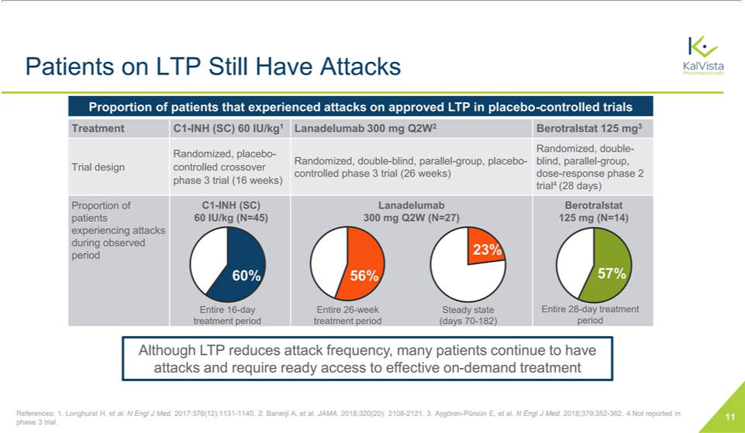

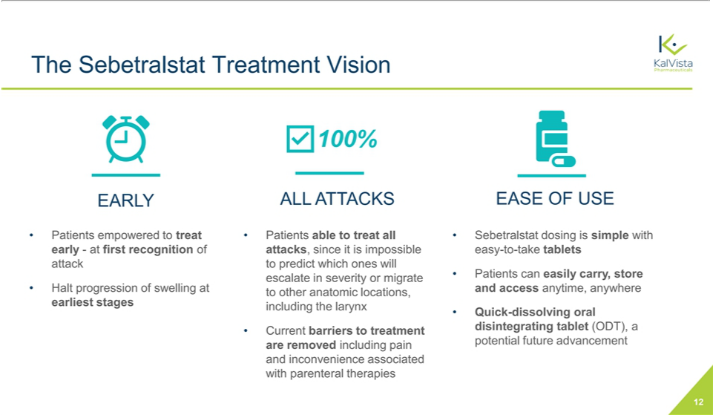

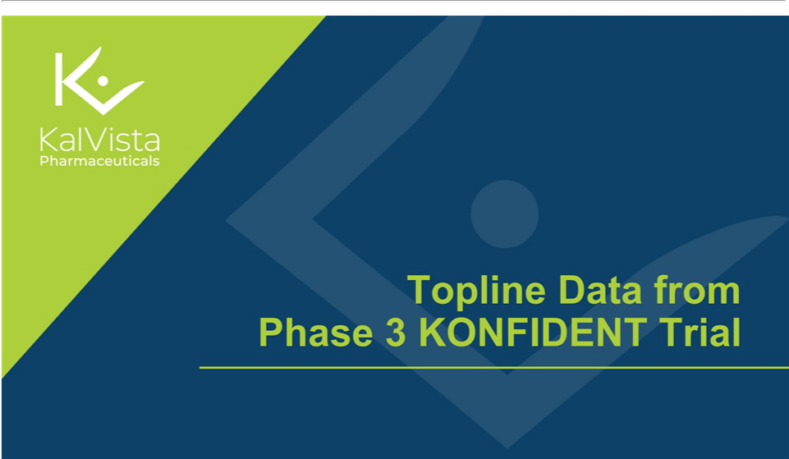

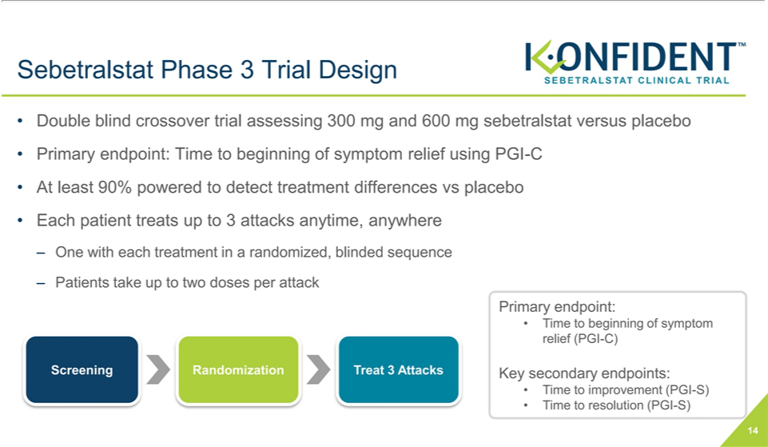

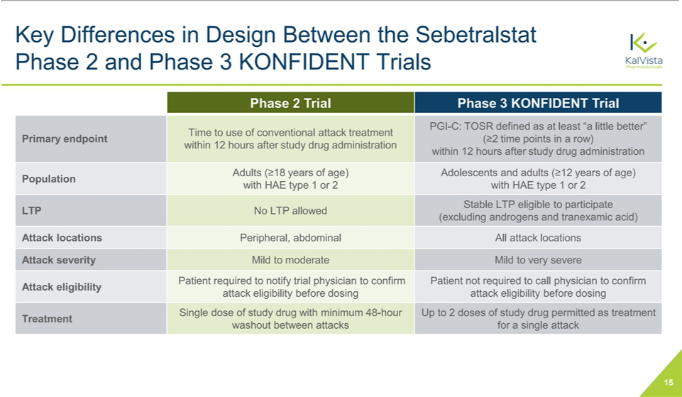

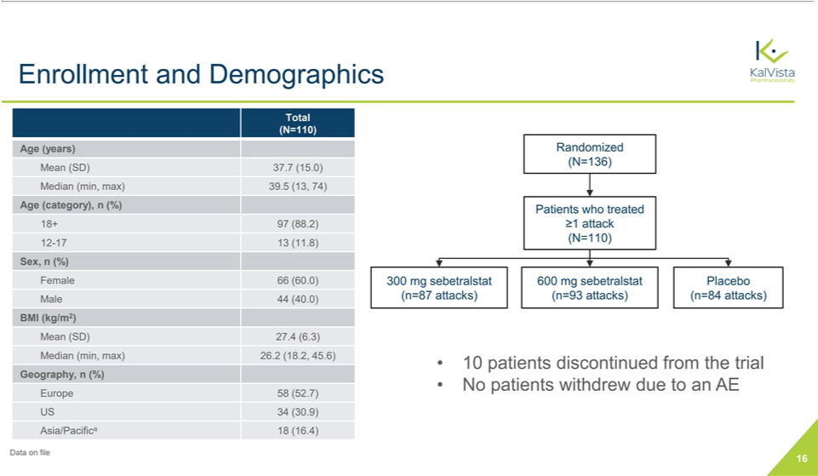

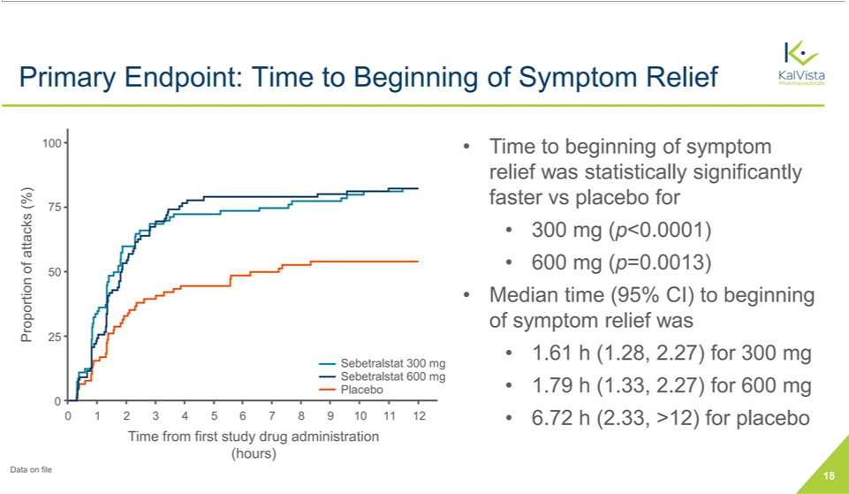

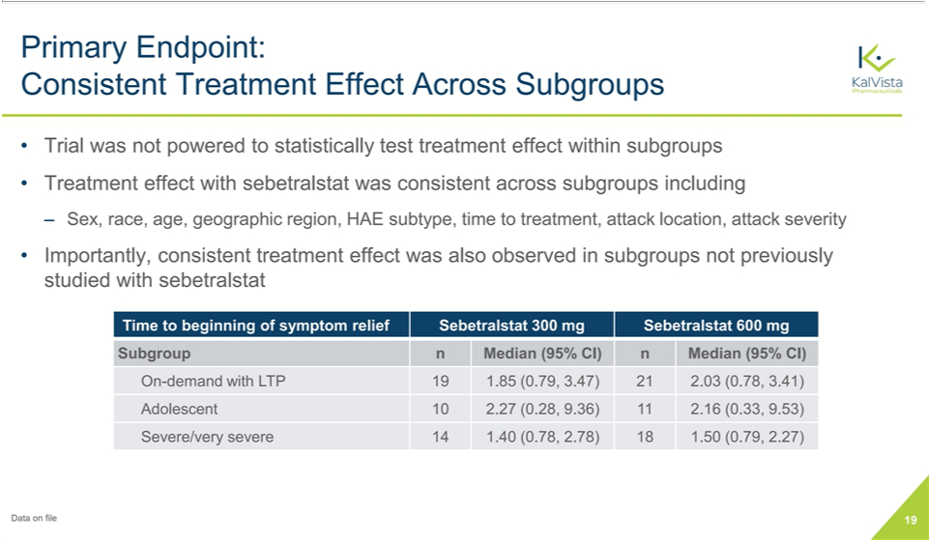

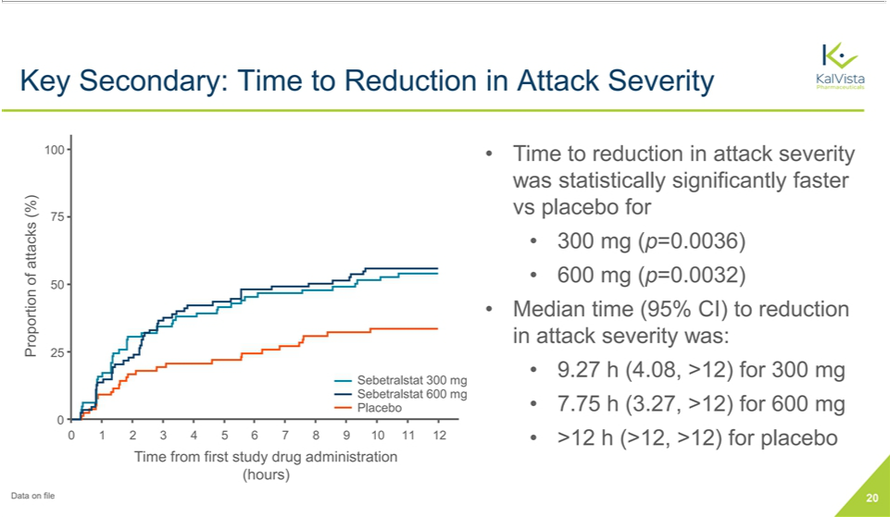

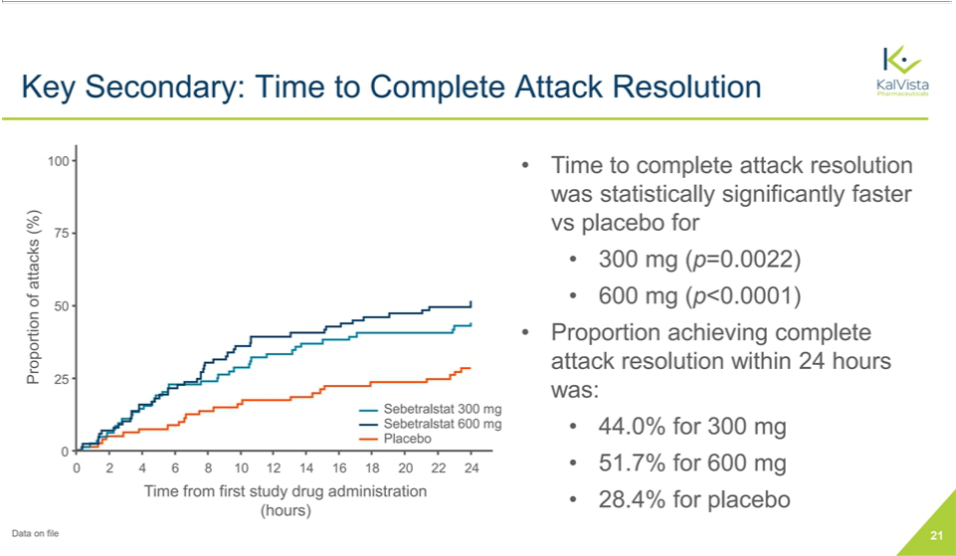

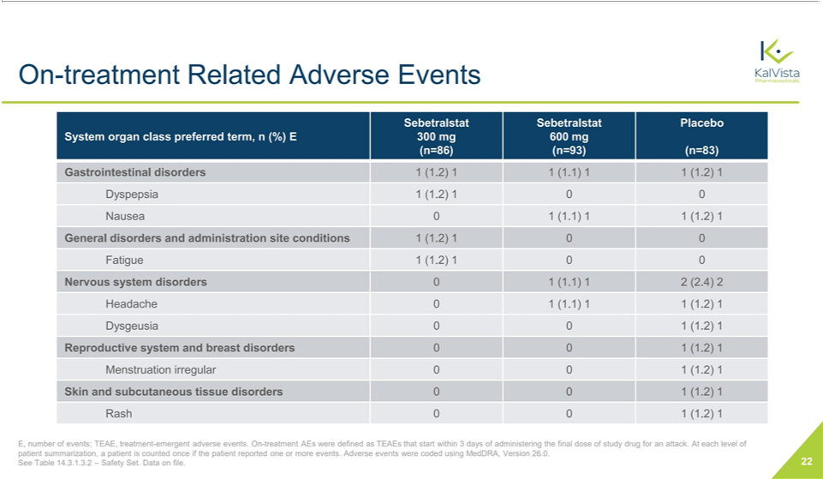

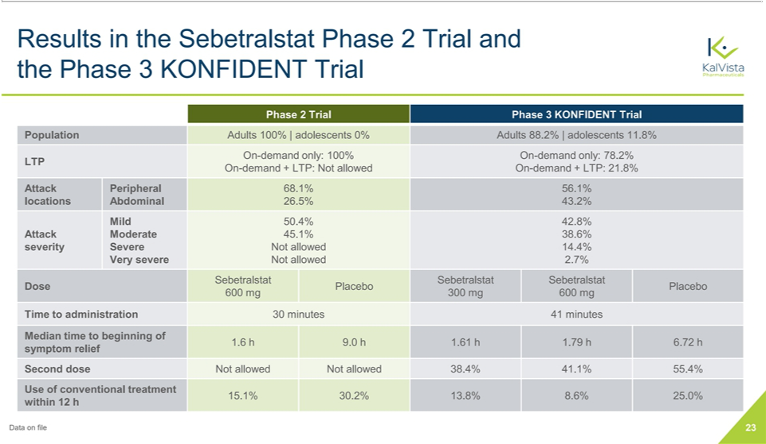

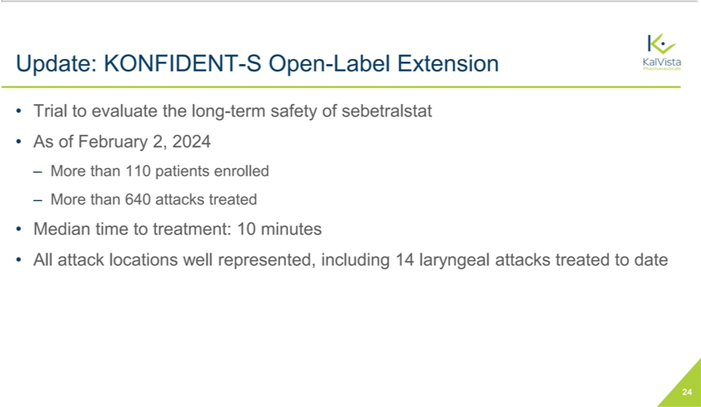

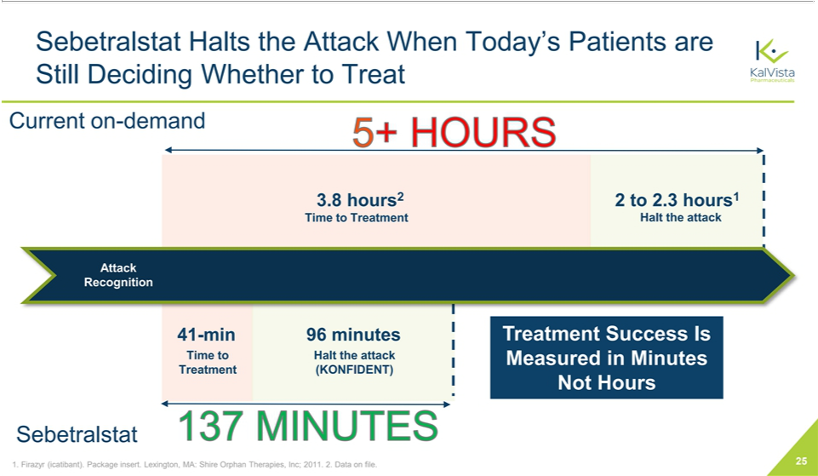

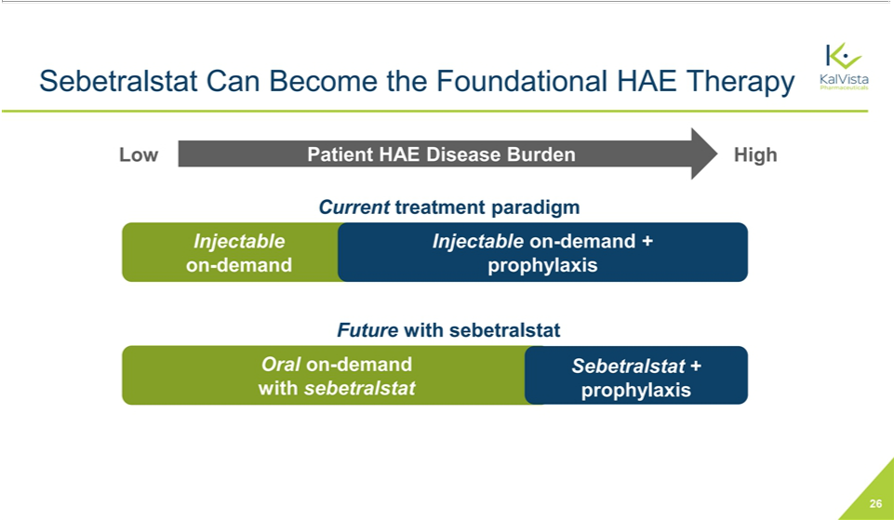

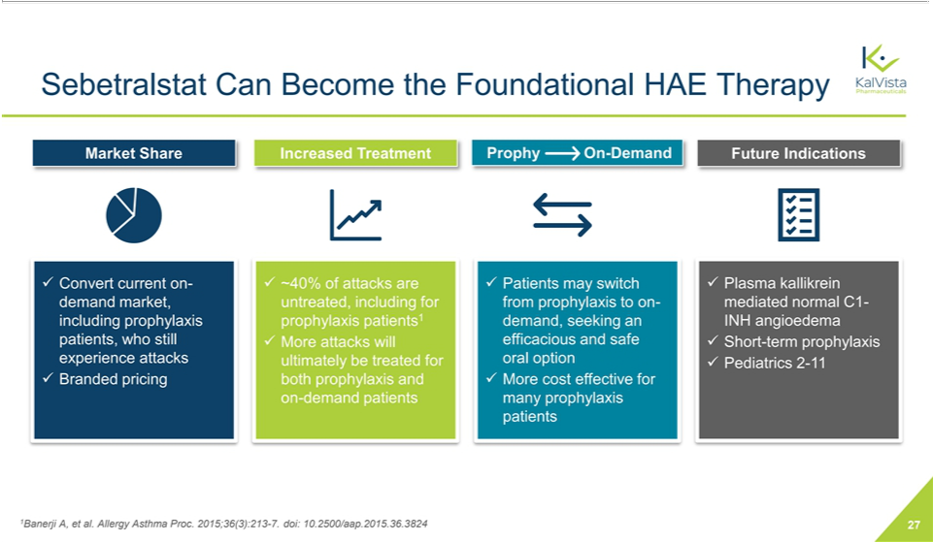

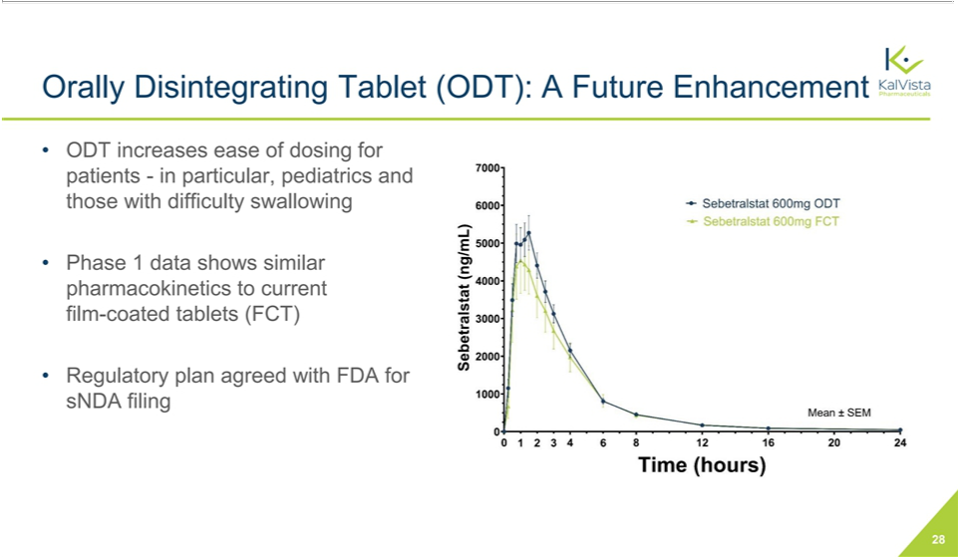

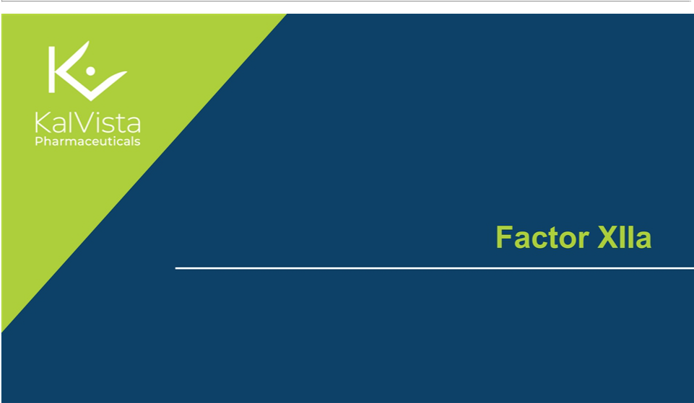

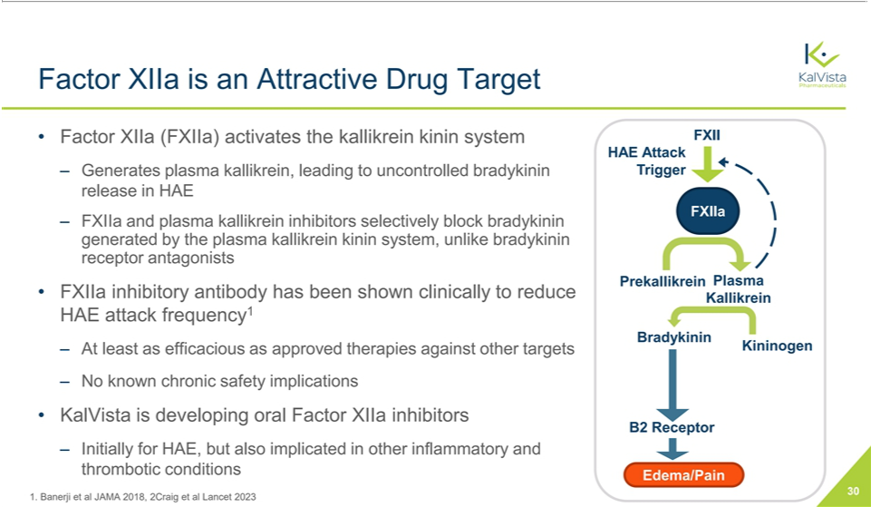

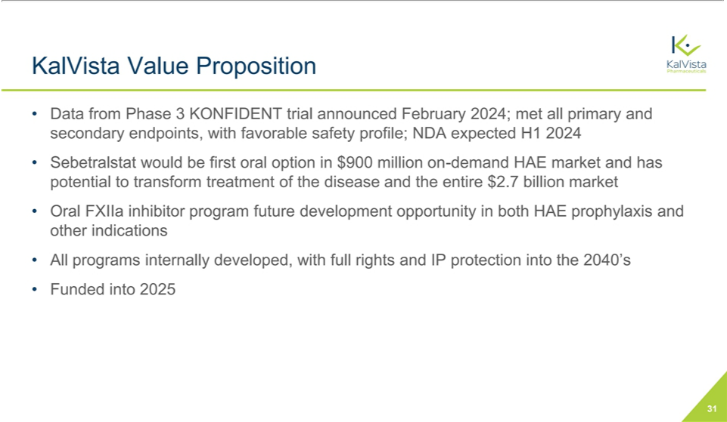

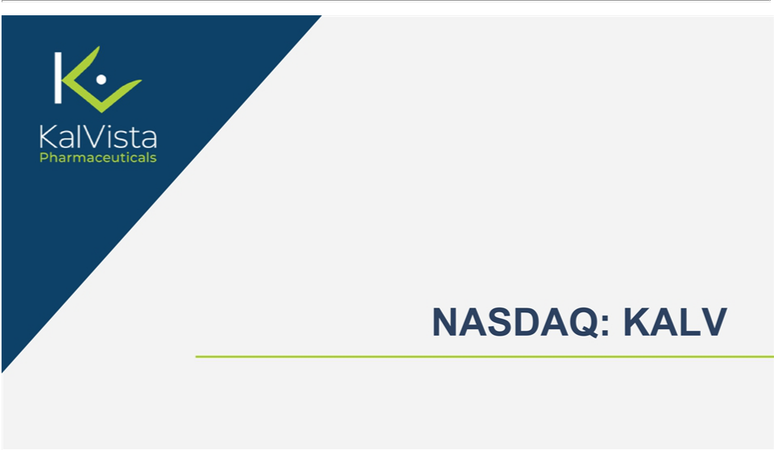

Exhibit 99.2

KalVista Pharmaceuticals Reports Phase 3 KONFIDENT Trial Meets All Endpoints for Sebetralstat as First Oral On-demand Therapy for Hereditary Angioedema

– Sebetralstat 300 mg achieved beginning of symptom relief in 1.6 hours –

– Safety profile comparable to placebo –

– On track for submission of new drug application to U.S. FDA in the first half of 2024 –

– Conference call to discuss trial results today at 8:30 a.m. ET –

CAMBRIDGE, Mass. & SALISBURY, England – February 13, 2024 – KalVista Pharmaceuticals, Inc. (NASDAQ: KALV), a clinical stage pharmaceutical company focused on the discovery, development, and commercialization of small molecule protease inhibitors, today announced positive results from the phase 3 KONFIDENT clinical trial demonstrating statistically and clinically significant efficacy of sebetralstat as oral on-demand therapy for hereditary angioedema (HAE). KONFIDENT was the largest and most representative trial ever conducted in HAE, and included adolescents, patients using long-term prophylaxis, and all attack severities and locations.

The clinical trial met all primary and key secondary endpoints and demonstrated a favorable safety profile. HAE attacks treated with both 300 mg and 600 mg of sebetralstat achieved the primary endpoint of beginning of symptom relief significantly faster than placebo (p<0.0001 for 300 mg, p=0.0013 for 600 mg). The median time to beginning of symptom relief was 1.61 hours with sebetralstat 300 mg (CI 1.28, 2.27), 1.79 hours with sebetralstat 600 mg (CI 1.33, 2.27) and 6.72 hours with placebo (CI 2.33, >12).

Consistent with previous studies, sebetralstat was well-tolerated, with a safety profile similar to placebo. There were no patient withdrawals due to any adverse event and no treatment-related serious adverse events (SAEs) were observed. Treatment-related adverse event rates were 2.3% for 300 mg sebetralstat, 2.2% for 600 mg sebetralstat, and 4.8% for placebo.

“We are thrilled to announce positive phase 3 results for the KONFIDENT trial, which we believe position sebetralstat to become the first oral, on-demand therapy for the treatment of HAE. These clinically meaningful results represent a potentially significant advance for people living with HAE. If approved, sebetralstat may offer a compelling treatment option for patients and their caregivers given the long-standing preference for an effective and safe oral therapy that provides rapid symptom relief for HAE attacks,” said Andrew Crockett, Chief Executive Officer of KalVista.

Mr. Crockett added, “Most importantly, we want to thank the people living with HAE, their families, and the investigator teams around the world who supported KONFIDENT and made it the largest clinical trial ever conducted in HAE. We look forward to submitting a new drug application for sebetralstat to the U.S. FDA in the first half of 2024 and in the EU and Japan later this year.”

Primary and key secondary endpoints were analyzed in a fixed, hierarchical sequence and adjusted for multiplicity. Key secondary endpoints showed:

- Attacks treated with sebetralstat 300 mg or 600 mg achieved a significantly faster time to a reduction in attack severity from baseline, compared to placebo (p=0.0036 for 300 mg and p=0.0032 for 600 mg)

- Attacks treated with sebetralstat 300 mg or 600 mg demonstrated a significantly faster time to complete attack resolution, compared to placebo (p=0.0022 for 300 mg and p<0.0001 for 600 mg)

1

“These highly encouraging phase 3 results show that sebetralstat provided rapid symptom relief in a broad HAE population that reflects my clinical practice,” said Danny Cohn, MD, PhD, Department of Vascular Medicine, University of Amsterdam, and principal investigator for the KONFIDENT phase 3 trial. “If approved, sebetralstat could transform the management of HAE.”

“With no new on-demand therapies for HAE approved for nearly a decade, having a safe and effective oral, on-demand treatment for HAE attacks could be immensely valuable in addressing unmet needs and reducing the treatment burden associated with current injectable treatments,” said Marc A. Riedl, MD, professor of medicine and clinical director, U.S. Hereditary Angioedema Association Center at the University of California, San Diego, and an investigator for the KONFIDENT phase 3 trial. “Against the backdrop of patient needs and opportunities, the results of this trial with sebetralstat are extremely encouraging for the HAE community.”

The Company plans to present phase 3 data for the KONFIDENT trial at the annual meeting of the American Academy of Allergy Asthma and Immunology (AAAAI) on February 25, 2024.

Webcast Details

KalVista will host a webcast today at 8:30am ET. In conjunction, the Company will post a presentation with data from the phase 3 KONFIDENT trial of sebetralstat on the investors section of the company website. Stockholders and other interested parties may participate in the call by following the instructions below. The live webcast can be accessed on the Event Calendar portion of the KalVista investor page. A replay will be available on the KalVista website shortly after completion of the event and will be archived for up to 30 days.

Webcast Link: https://edge.media-server.com/mmc/p/mzfxtn9e

Participant Call Link: https://register.vevent.com/register/BI9a15a8c461b94eca9b3f649b83cdec60

About the KONFIDENT Phase 3 Trial

The KONFIDENT phase 3 trial was a randomized, double blind, event-driven, crossover clinical trial evaluating the efficacy and safety of sebetralstat 300 mg and 600 mg versus placebo for the on-demand treatment of HAE. The trial enrolled a total of 136 adult and adolescent HAE patients from 66 clinical sites across 20 countries, making it the largest clinical trial ever conducted in HAE. In the trial, patients treated each eligible attack with up to two doses of study drug, and each patient could treat up to three attacks over the course of the study. The trial included type 1 and type 2 HAE patients who had at least two attacks in 90 days prior to enrollment.

About Sebetralstat

Discovered by KalVista, sebetralstat is an investigational novel, oral plasma kallikrein inhibitor for the on-demand treatment of hereditary angioedema (HAE). Sebetralstat received Fast Track and Orphan Drug designations from the U.S. FDA, as well as Orphan Drug Designation and an approved Pediatric Investigational Plan from the European Medicines Agency (EMA).

About Hereditary Angioedema

Hereditary angioedema (HAE) is a rare genetic disease resulting in deficiency or dysfunction in the C1 esterase inhibitor (C1INH) protein and subsequent uncontrolled activation of the kallikrein-kinin system. People living with HAE experience painful and debilitating attacks of tissue swelling in various locations of the body that can be life-threatening depending on the location affected. All currently approved on-demand treatment options require either intravenous or subcutaneous administration.

2

About KalVista Pharmaceuticals, Inc.

KalVista Pharmaceuticals, Inc. is a pharmaceutical company focused on the discovery, development, and commercialization of oral, small molecule protease inhibitors for diseases with significant unmet need. KalVista disclosed positive phase 3 data for the KONFIDENT trial for its oral, on-demand therapy sebetralstat in February 2024. The Company anticipates submitting a new drug application to the U.S. FDA for sebetralstat in the first half of 2024 and expects to file for approval in Europe and Japan later in 2024. In addition, KalVista’s oral Factor XIIa inhibitor program represents a new generation of therapies that may further improve the treatment for people living with HAE and other diseases.

For more information about KalVista, please visit www.kalvista.com.

Forward-Looking Statements

This press release contains “forward-looking” statements within the meaning of the safe harbor provisions of the U.S. Private Securities Litigation Reform Act of 1995. Forward-looking statements can be identified by words such as: “anticipate,” “intend,” “plan,” “goal,” “seek,” “believe,” “project,” “estimate,” “expect,” “strategy,” “future,” “likely,” “may,” “should,” “will” and similar references to future periods. These statements are subject to numerous risks and uncertainties that could cause actual results to differ materially from what we expect. Examples of forward-looking statements include, among others, timing or outcomes of communications with the FDA, our expectations about safety and efficacy of our product candidates and timing of clinical trials and its results, our ability to commence clinical studies or complete ongoing clinical studies, including our Phase 3 KONFIDENT trial, and to obtain regulatory approvals for sebetralstat and other candidates in development, the success of any efforts to commercialize sebetralstat, the ability of sebetralstat and other candidates in development to treat HAE or other diseases, and the future progress and potential success of our oral Factor XIIa program. Further information on potential risk factors that could affect our business and financial results are detailed in our filings with the Securities and Exchange Commission, including in our annual report on Form 10-K for the year ended April 30, 2023, our quarterly reports on Form 10-Q, and our other reports that we may make from time to time with the Securities and Exchange Commission. We undertake no obligation to publicly update any forward-looking statement, whether written or oral, that may be made from time to time, whether as a result of new information, future developments or otherwise.

Contacts:

KalVista Pharmaceuticals, Inc.

Jarrod Aldom

Vice President, Corporate Communications

- 705-0254 jarrod.aldom@kalvista.com

Ryan Baker

Head, Investor Relations

- 771-5001 ryan.baker@kalvista.com

3

